

Data Technician

Name: Kieran Salaria
Course Date: 9th December 2025
Table of contents
Day 2: Task 1 3
Day 2: Task 2 (If completed Day 2 Task 1 Early) 6
Day 4: Task 1 9
Day 4: Task 2 10
Day 4: Task 3 11
Day 4: Task 4 ((If completed other tasks early) 12
Course Notes 13
Additional Information 14

Day 2: Task 1
Start new Tableau page.
Using the Health GapminderHealth.xlsx, conduct an analysis to find trends and key information that could be used by an organisation for future support.

Scenario:
You are a data analyst working for a global health organization. Your team needs to quickly understand key health trends and disparities across different countries and continents. They are particularly interested in seeing how health metrics vary and how life expectancy has changed over time.
Your Task:
Using the GapminderHealth dataset in Tableau, create a series of visualizations to answer the following questions. Focus on using basic chart types and features.
Instructions & Deliverables:
- Life Expectancy by Continent (Most Recent Year):
  - Create a bar chart showing the average Life Expectancy for each Continent.
  - Filter the data to show only the most recent year available in the dataset.
  - Sort the continents by Life Expectancy in ascending or descending order.
  - Deliverable: A worksheet named "Life Expectancy by Continent".
- Life Expectancy Trend Over Time (Top 5 Countries):
  - Create a line chart to show the trend of Average Life Expectancy over Year.
  - Filter the data to display only the top 5 countries with the highest average Life Expectancy across all years. (Hint: Use a Top N filter on Country based on Average Life Expectancy).
  - Use Country on Color to differentiate the lines.
  - Deliverable: A worksheet named "Life Expectancy Trend".
- Population Distribution by Gender (Latest Year for a Selected Country):
  - Create a pie chart showing the Population distribution by Gender.
  - Add a Country filter to the worksheet (e.g., set it to 'United States' or a country of your choice initially, but ensure the filter is available for interaction). Change filter type to Single Value (dropdown).
  - Filter the data to show only the most recent year available in the dataset.
  - Add Population to Labels. Right click on sum(Population) under marks card and change Quick table calculation to Percentage of Total.
  - Deliverable: A worksheet named "Population by Gender".

- Health Metric Comparison (Scatter Plot):
  - Create a scatter plot to explore the relationship between Average Life Expectancy and Average BMI.
  - Place Life Expectancy on one axis and BMI on the other.
  - Use Country on Detail to represent individual countries as points.
  - Use Continent on Color to differentiate points by continent.
  - Add Continent to filters and show filter.
  - Deliverable: A worksheet named "Life Expectancy vs BMI".
- Viz of your Choice
  - Use any other fields or chart types to add another visual.

- Dashboard Creation:
  - Combine all worksheets (Life Expectancy by Continent, Life Expectancy Trend, Population by Gender, Life Expectancy vs BMI, Viz of your Choice) into a single dashboard.
  - Ensure the "Country" filter on the "Population by Gender" worksheet applies to the "Life Expectancy Trend" worksheet as well (if applicable, or make it a global filter if you prefer the user to select one country to see all relevant details for it). Self-correction: Given it's basic, let's keep the filters simple. Just place the filter on the dashboard and ensure it's applied to the relevant sheet(s) where it makes sense.
  - Add a Title to your dashboard, e.g., "Global Health Insights".
  - Publish your dashboard to Tableau Public Website
  - Deliverable: A dashboard named "Global Health Dashboard".

Paste your dashboard screens here | 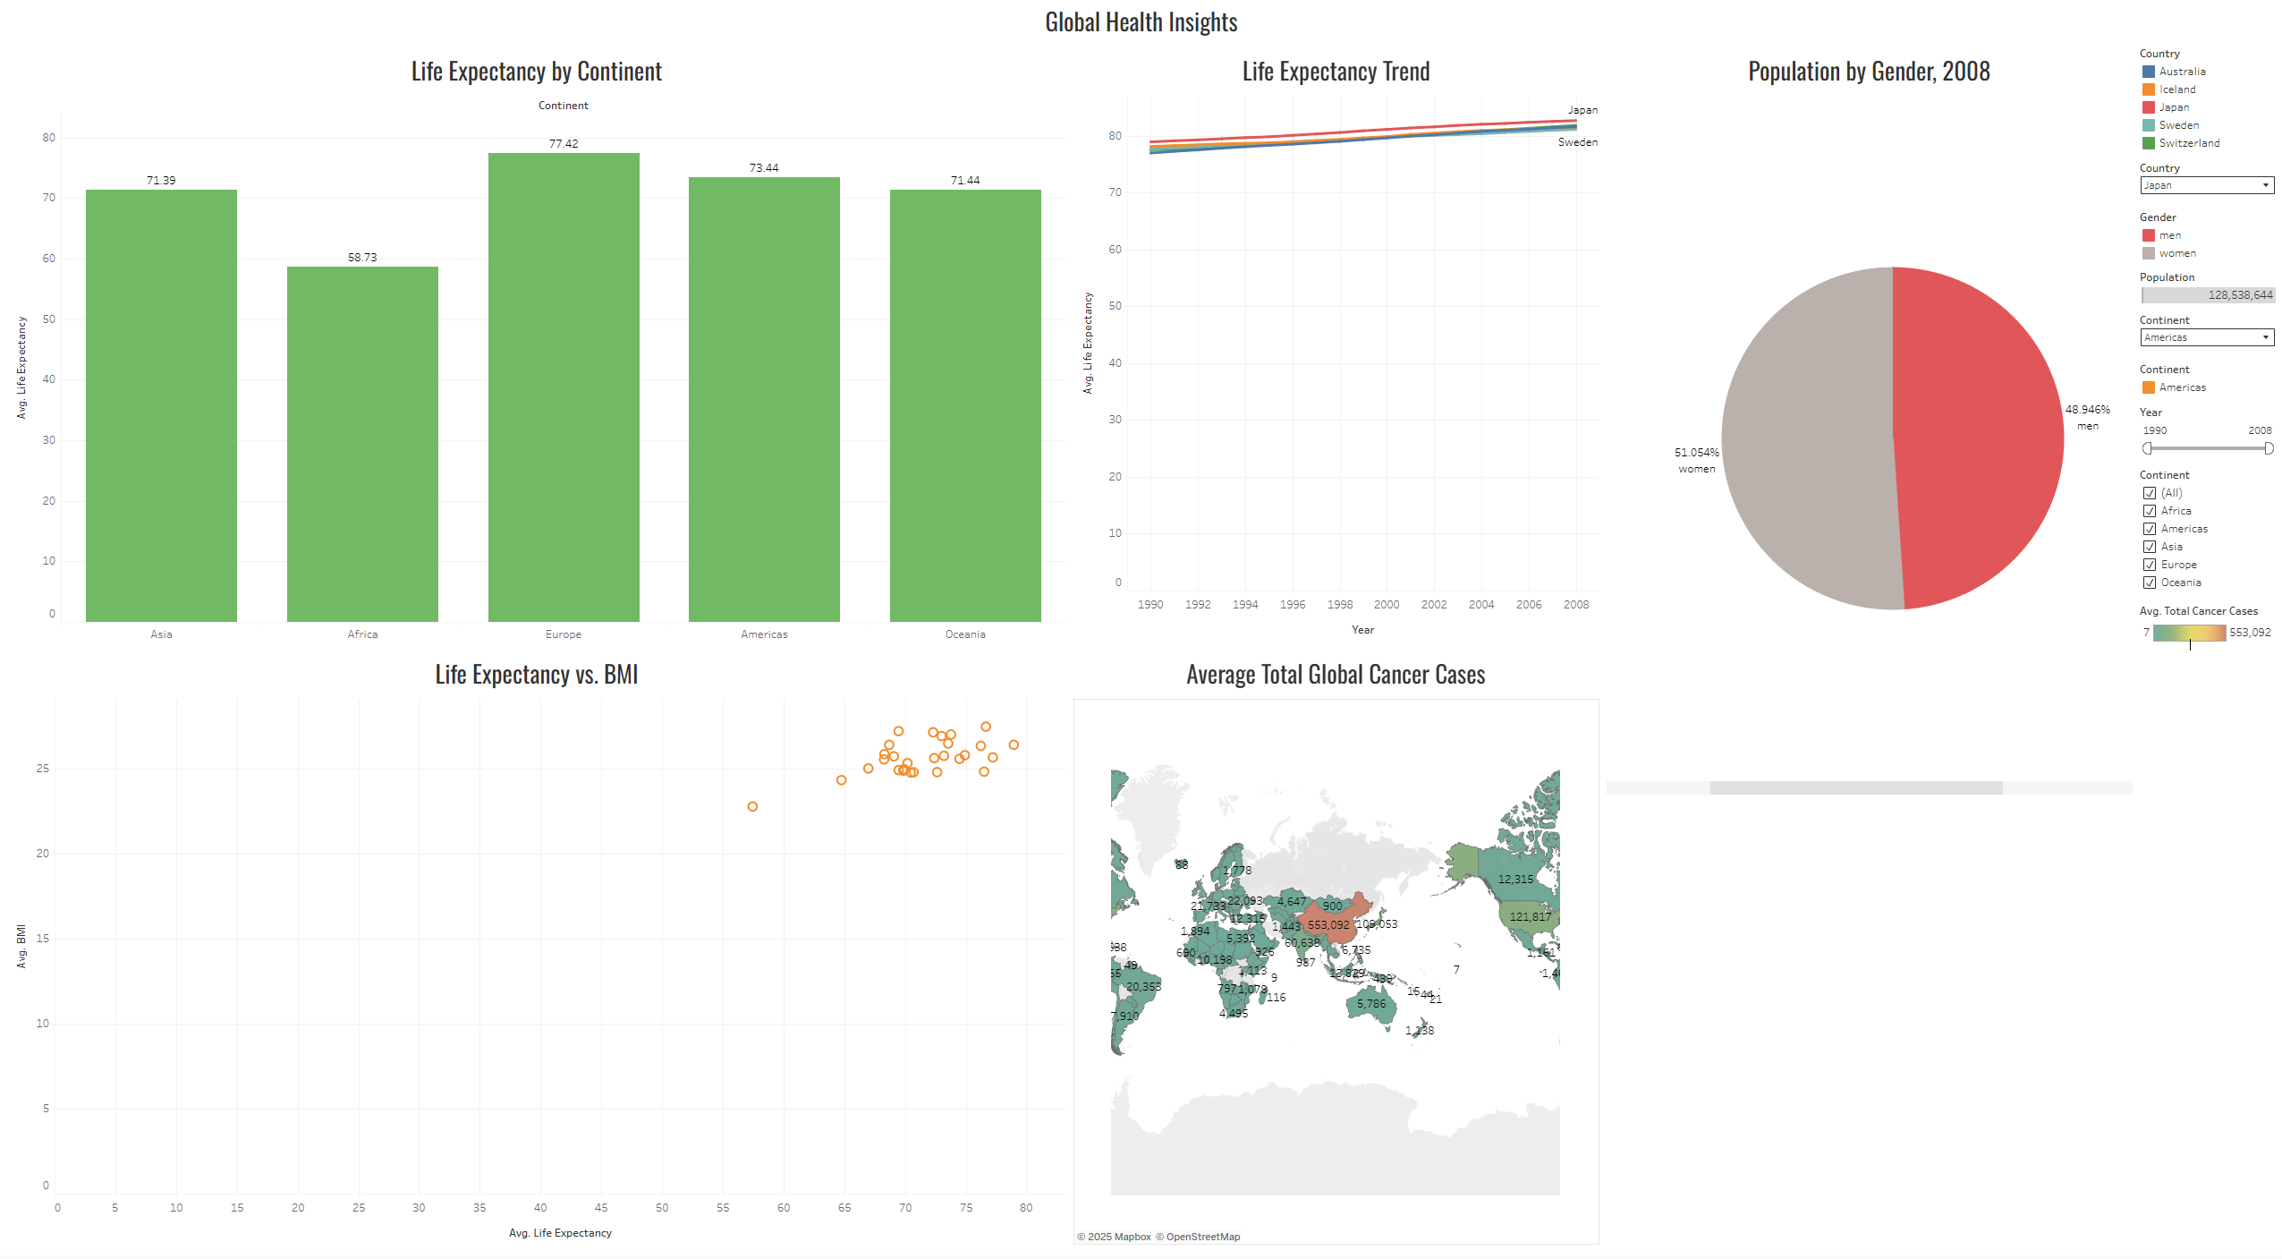  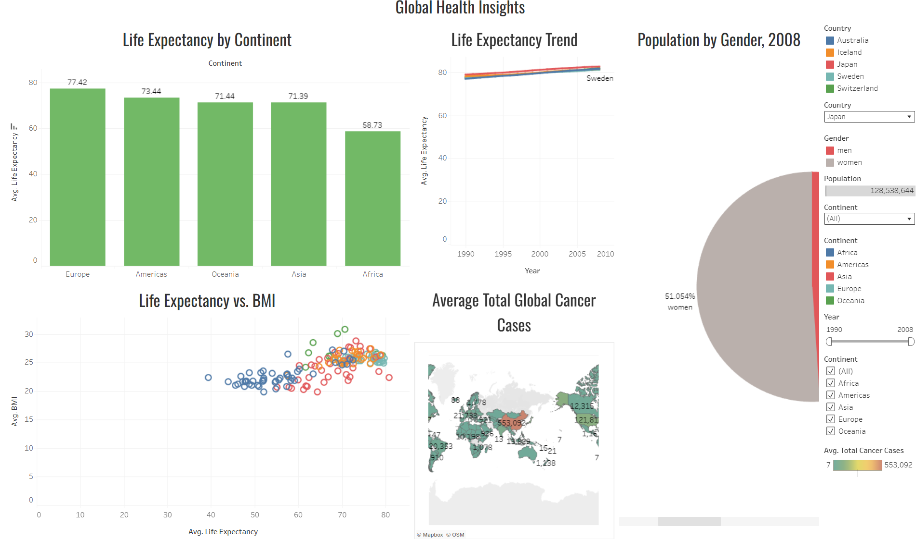
What did you find and any reflections on how the NHS could use this? | I found that Europe had the greatest life expectancy average of all the continents, while Japan had the greatest life expectancy on average. African countries generally show a smaller life expectancy rate compared to other countries.  The NHS could potentially use this information to enrich their knowledge on a global scale, understanding health issues in other countries as well as their severities could help inform their own practices.
Link to your dashboard | https://public.tableau.com/shared/X6GQBN5CK?:display_count=n&:origin=viz_share_link

Once you finish this task save and close Tableau.

Day 2: Task 2 (If completed Day 2 Task 1 Early)

Start Tableau Public Desktop and import the Spotify dataset Extension_Task_SpotifyFeatures.csv, conduct an analysis to find trends and key information that could be used by an organisation for future projects. Use Text File under Connect Pane to import the dataset. This is a CSV file.

Column Description
- genre: The genre in which the track belongs
- artist_name: The artists' names who performed the track. If there is more than one artist, they are separated by a ;
- track_name: Name of the track
- track_id: The Spotify ID for the track
- popularity: The popularity of a track is a value between 0 and 100, with 100 being the most popular. The popularity is calculated by algorithm and is based, in the most part, on the total number of plays the track has had and how recent those plays are. Songs that are being played a lot now will have a higher popularity than songs that were played a lot in the past. Duplicate tracks (e.g. the same track from a single and an album) are rated independently. Artist and album popularity is derived mathematically from track popularity.
- acousticness: A confidence measure from 0.0 to 1.0 of whether the track is acoustic. 1.0 represents high confidence the track is acoustic
- danceability: Danceability describes how suitable a track is for dancing based on a combination of musical elements including tempo, rhythm stability, beat strength, and overall regularity. A value of 0.0 is least danceable and 1.0 is most danceable
- duration_ms: The track length in milliseconds
- energy: Energy is a measure from 0.0 to 1.0 and represents a perceptual measure of intensity and activity. Typically, energetic tracks feel fast, loud, and noisy. For example, death metal has high energy, while a Bach prelude scores low on the scale
- instrumentalness: Predicts whether a track contains no vocals. "Ooh" and "aah" sounds are treated as instrumental in this context. Rap or spoken word tracks are clearly "vocal". The closer the instrumentalness value is to 1.0, the greater likelihood the track contains no vocal content
- key: The key the track is in. Integers map to pitches using standard Pitch Class notation. E.g. 0 = C, 1 = C♯/D♭, 2 = D, and so on. If no key was detected, the value is -1
- liveness: Detects the presence of an audience in the recording. Higher liveness values represent an increased probability that the track was performed live. A value above 0.8 provides strong likelihood that the track is live
- loudness: The overall loudness of a track in decibels (dB)
- mode: Mode indicates the modality (major or minor) of a track, the type of scale from which its melodic content is derived. Major is represented by 1 and minor is 0
- speechiness: Speechiness detects the presence of spoken words in a track. The more exclusively speech-like the recording (e.g. talk show, audio book, poetry), the closer to 1.0 the attribute value. Values above 0.66 describe tracks that are probably made entirely of spoken words. Values between 0.33 and 0.66 describe tracks that may contain both music and speech, either in sections or layered, including such cases as rap music. Values below 0.33 most likely represent music and other non-speech-like tracks
- tempo: The overall estimated tempo of a track in beats per minute (BPM). In musical terminology, tempo is the speed or pace of a given piece and derives directly from the average beat duration
- time_signature: An estimated time signature. The time signature (meter) is a notational convention to specify how many beats are in each bar (or measure). The time signature ranges from 3 to 7 indicating time signatures of 3/4, to 7/4.
- valence: A measure from 0.0 to 1.0 describing the musical positiveness conveyed by a track. Tracks with high valence sound more positive (e.g. happy, cheerful, euphoric), while tracks with low valence sound more negative (e.g. sad, depressed, angry)

There is no set scope for the analysis, simply to find trends and document them below:

Paste your print screens here | 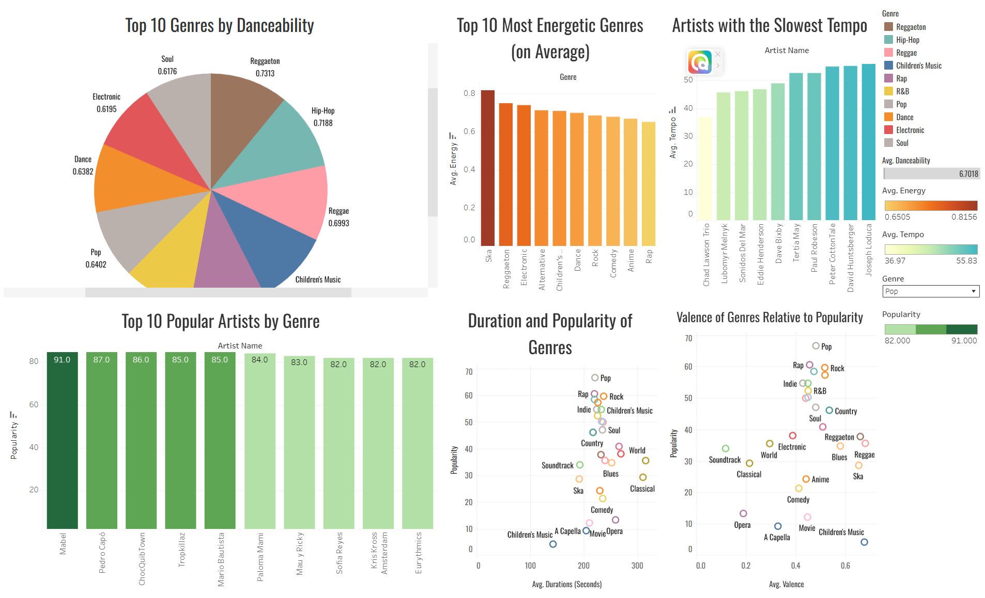

What did you find? | Reggaeton had the greatest danceability of all the genres.  Ska was the most energetic genre.  Chad Lawson Trio has music with the slowest tempo on average.  Bill Burr was the most popular comedy artist, Lauren Jaregui was the most popular R&B artist and Albert Lortzing was the most popular Opera singer (although his popularity is at 36, indicating a general lack of popularity for the Opera genre)  Pop is the most popular genre, but is neither the longest or most valent on average. The most valent genre is Reggae, and the longest genre on average is World music, followed by classical.  The most popular genres of music tend to be between 200 and 240 seconds long.  There is an indication of some positive correlation between popularity of a genre and its valence; the more happy and upbeat a genre is on average, the more popular it is. However, movie music and children’s music are clear outliers in this dataset due to being significantly less popular despite their valence.
Link to your dashboard | https://public.tableau.com/views/SpotifyStatistics_17652897752430/Dashboard1?:language=en-GB&:sid=&:redirect=auth&:display_count=n&:origin=viz_share_link

Day 4: Task 1
Please complete Tutorial: From Excel workbook to stunning report in Power BI Desktop - Power BI | Microsoft Learn.
Once complete, publish your report in Power BI service and paste a print screen below and in the collaboration board.
You can also watch this video how to publish and share power bi report.webm. and share with your trainer.
“Teaching is the best way to learn, so please listen out for support requests from the class and we’ll work through the challenges together”

Paste your completed lab here | 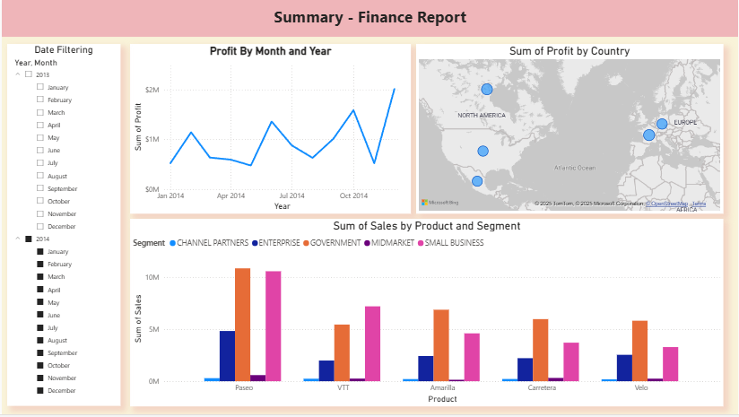  https://app.powerbi.com/links/eCAe3IciIp?ctid=3ea7c128-c601-4479-a003-e14d00c0b5cb&pbi_source=linkShare&bookmarkGuid=b57d8a47-f763-4b5c-ad8e-45e2b5707cc0

Day 4: Task 2

Please complete Tutorial: Combine data from Excel and an OData feed in Power BI Desktop - Power BI | Microsoft Learn.
Once complete, publish your report in Power BI service and paste a print screen below and share with your trainer.
You can also watch this video how to publish and share power bi report.webm.

Paste your completed lab here | 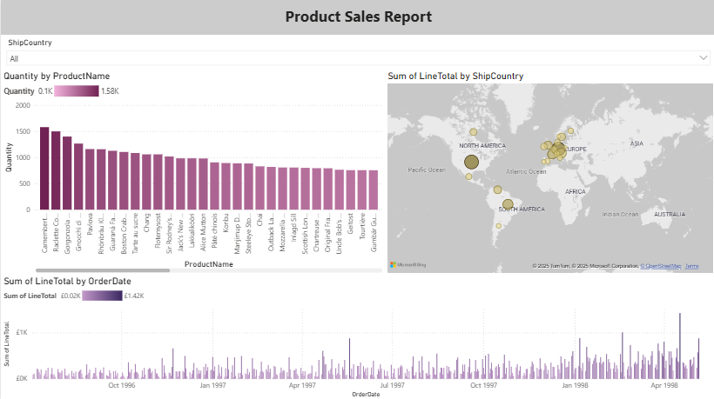  https://app.powerbi.com/links/O4bqQs_dE6?ctid=3ea7c128-c601-4479-a003-e14d00c0b5cb&pbi_source=linkShare

Day 4: Task 3

Please complete Exercise - Load Data in Power BI Desktop - Training | Microsoft Learn.
- Visit that page
- Select Sign In to launch Lab
- Sign in using Just IT email
- Complete puzzle
- Start Lab

Once complete, publish your report in Power BI service and paste a print screen below and share with your trainer.
You can also watch this video how to publish and share power bi report.webm.

Paste your completed lab here | Salesperson:  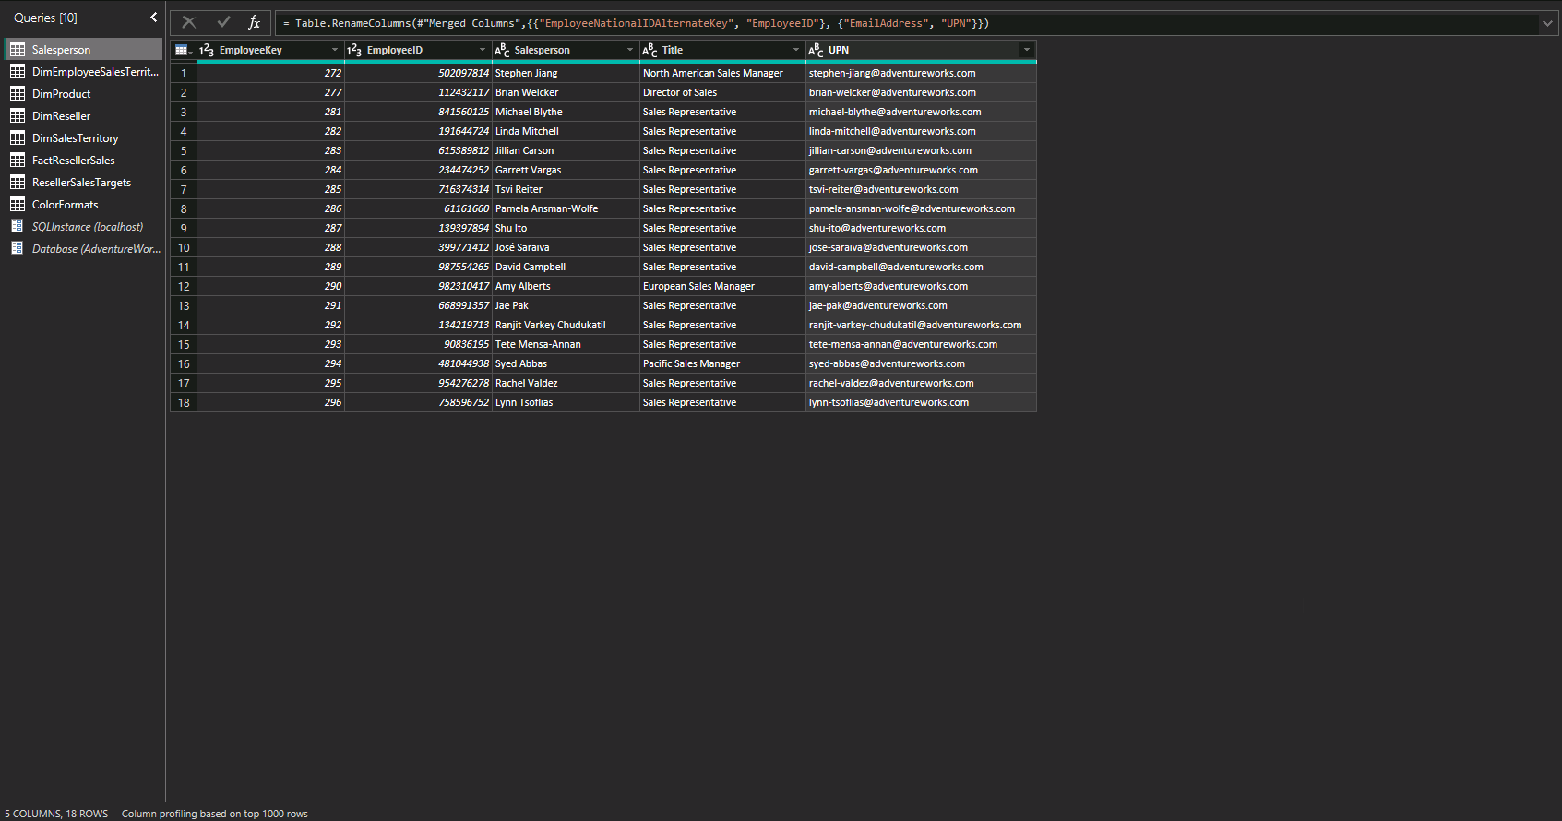  SalespersonRegion:  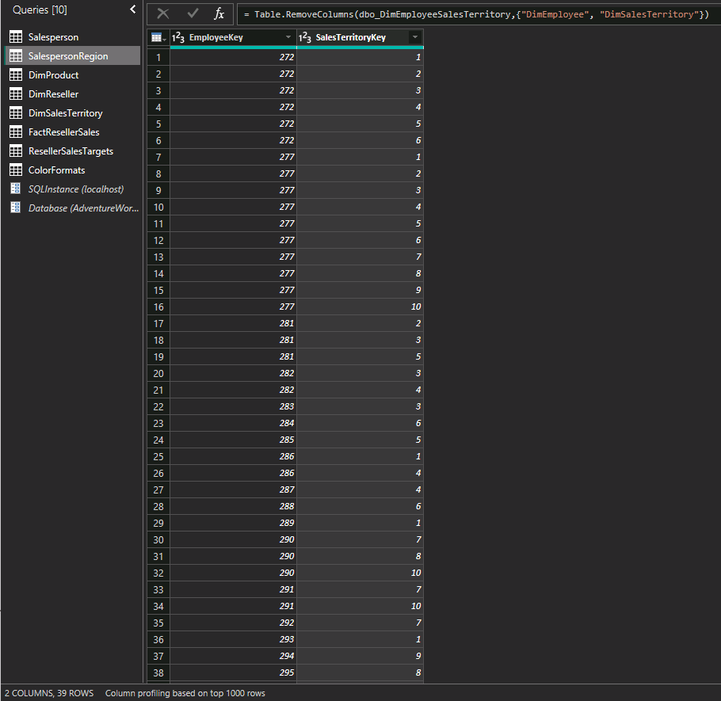  Product:  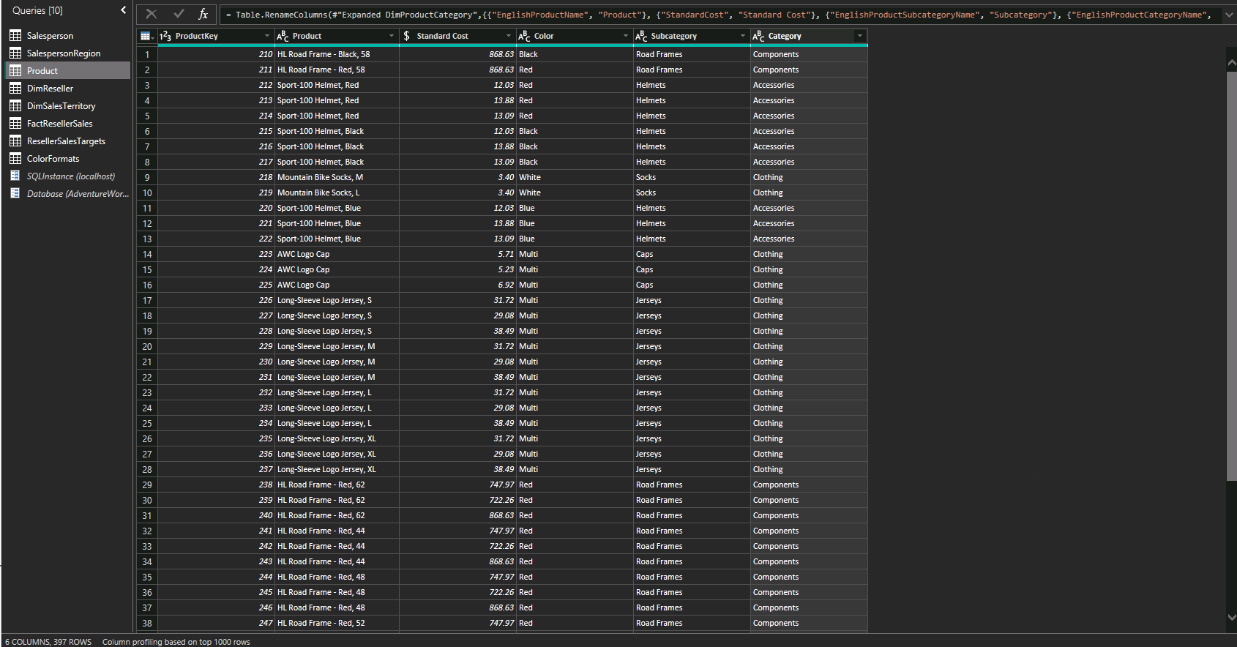  Reseller:  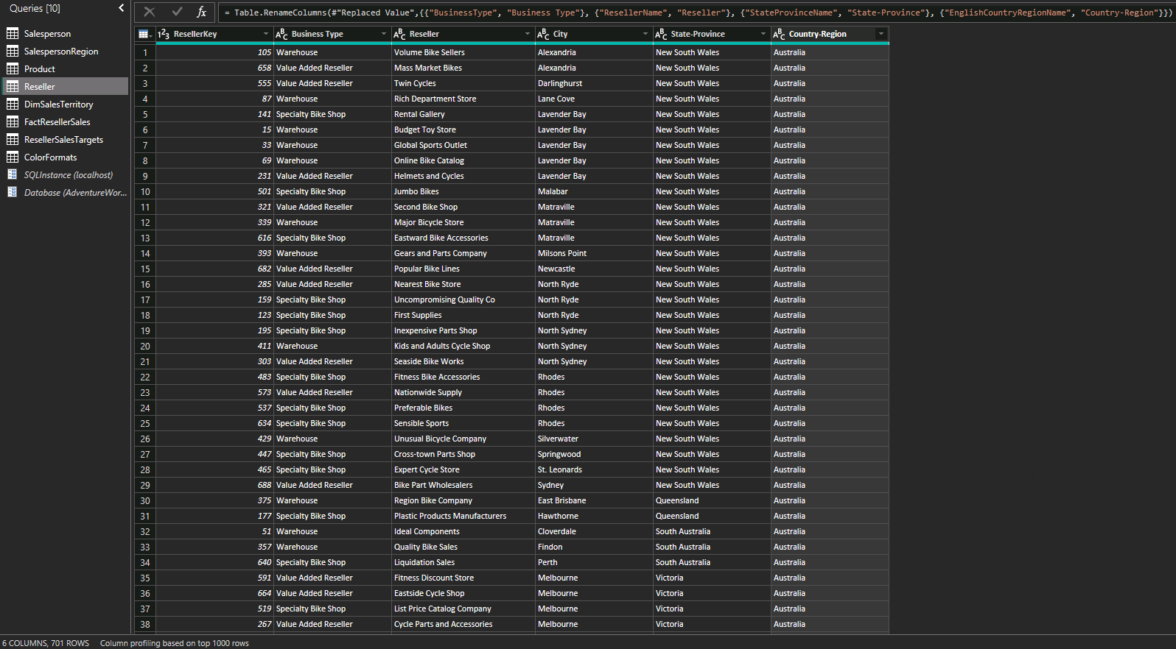  Sales:  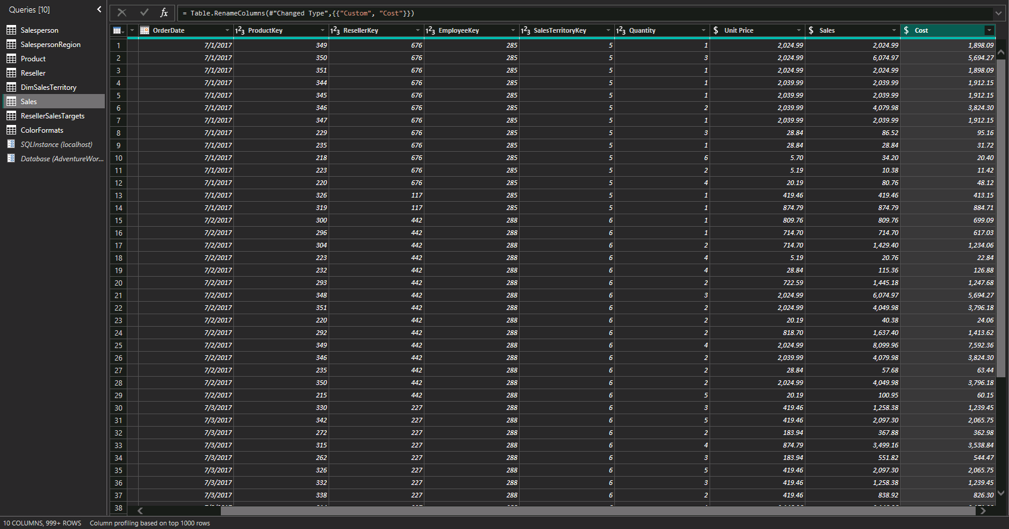  Targets:  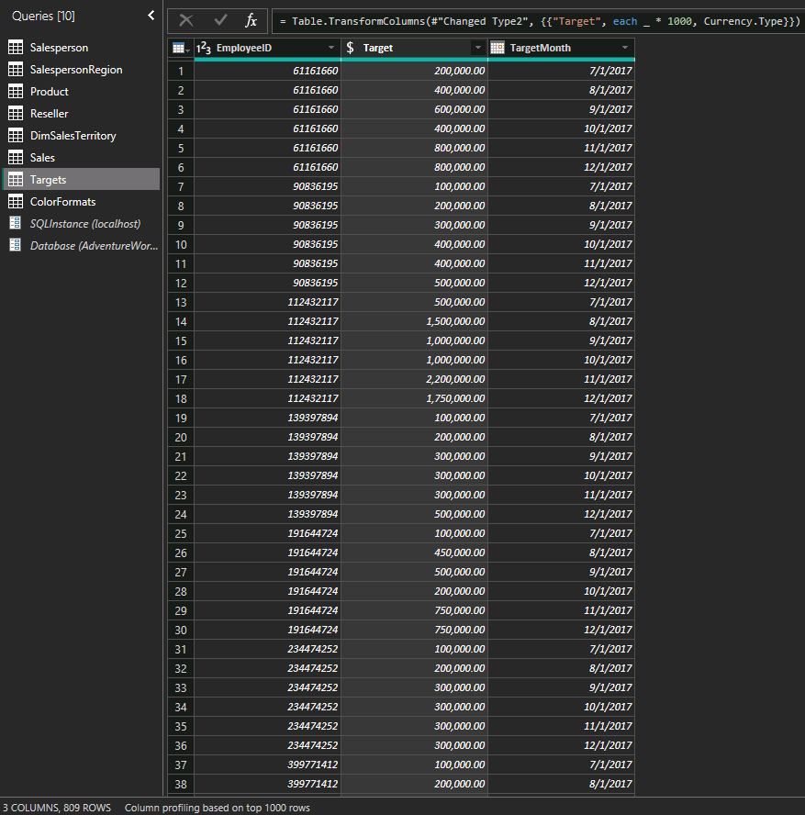  ColourFormats:  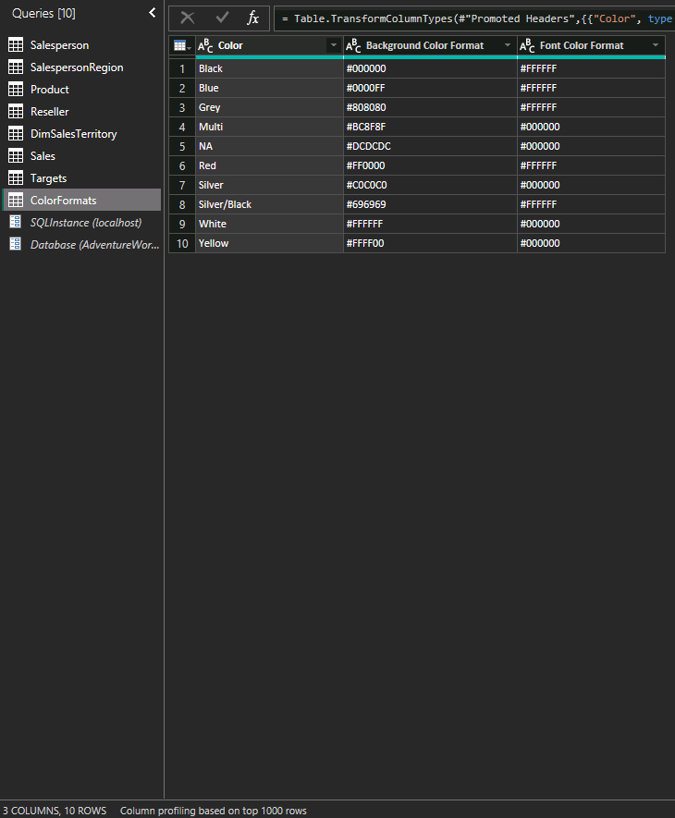  Updating Product:  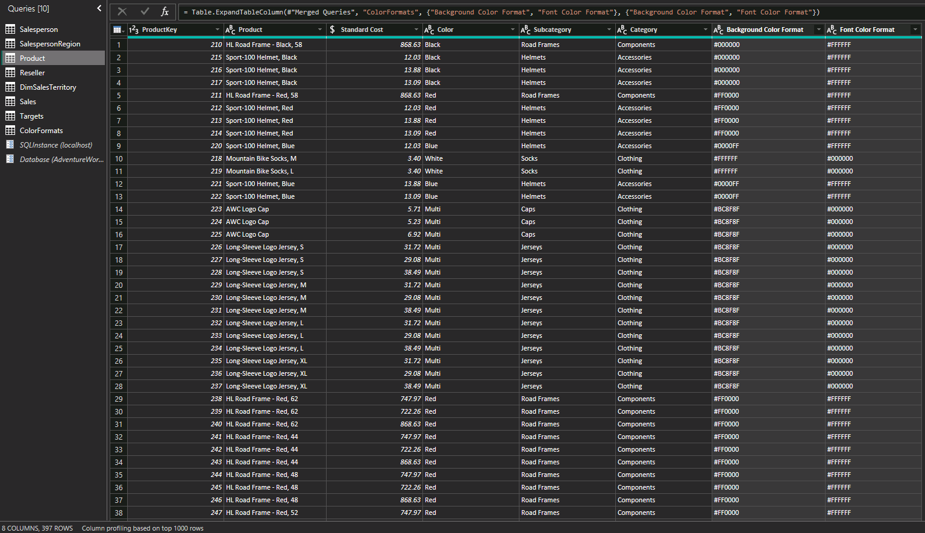  Updating ColourFormats:  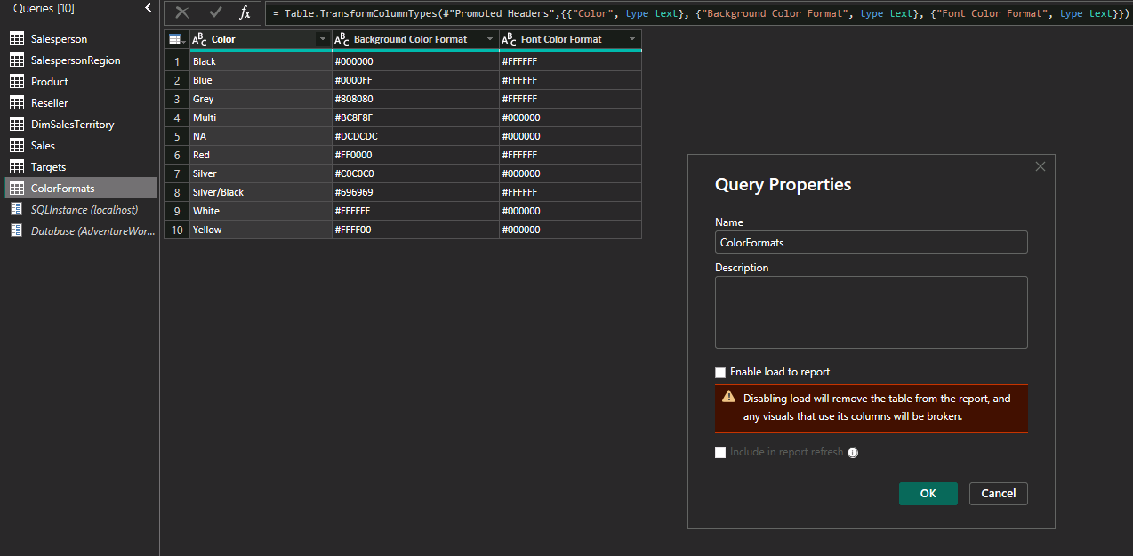  Canvas:  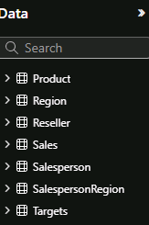

Day 4: Task 4 ((If completed other tasks early)

Please complete Exercise - Design Power BI Reports - Training | Microsoft Learn.
- Visit that page
- Select Sing in to launch Lab
- Sign in using Just IT email
- Complete puzzle
- Start Lab

Once complete, publish your report in Power BI service and paste a print screen below and share with your trainer.
You can also watch this video how to publish and share power bi report.webm.

Paste your completed lab here | Page 01:  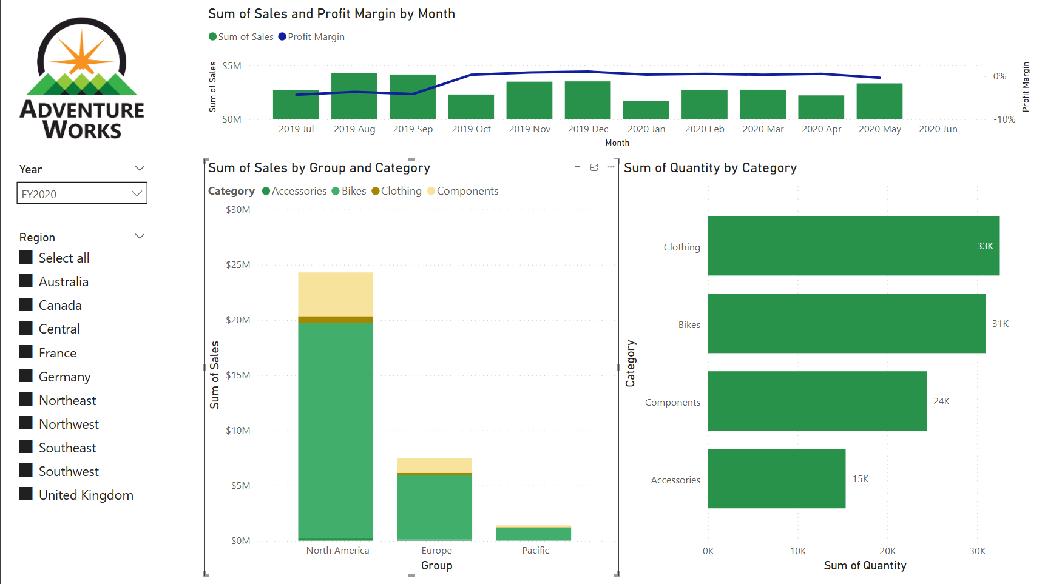  Page 02:  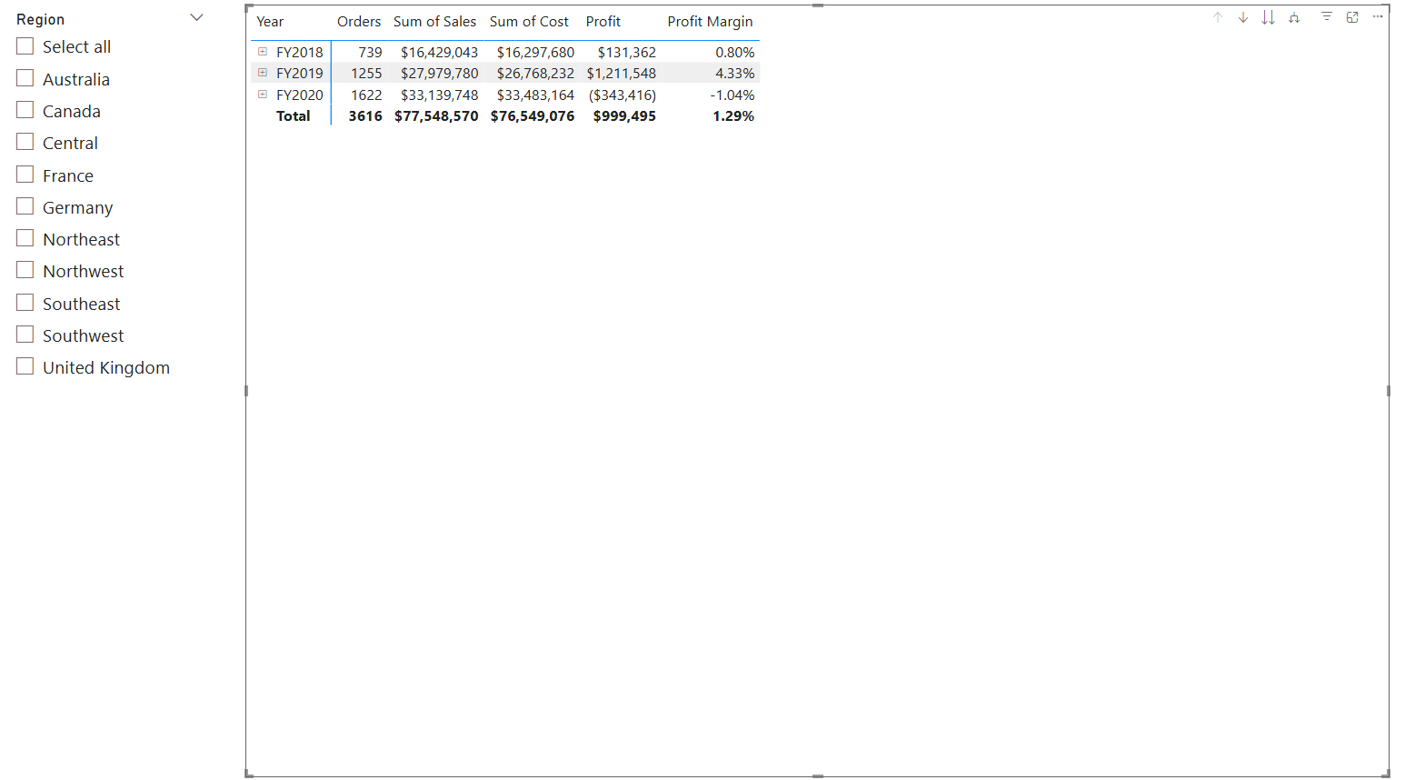  Page 03:  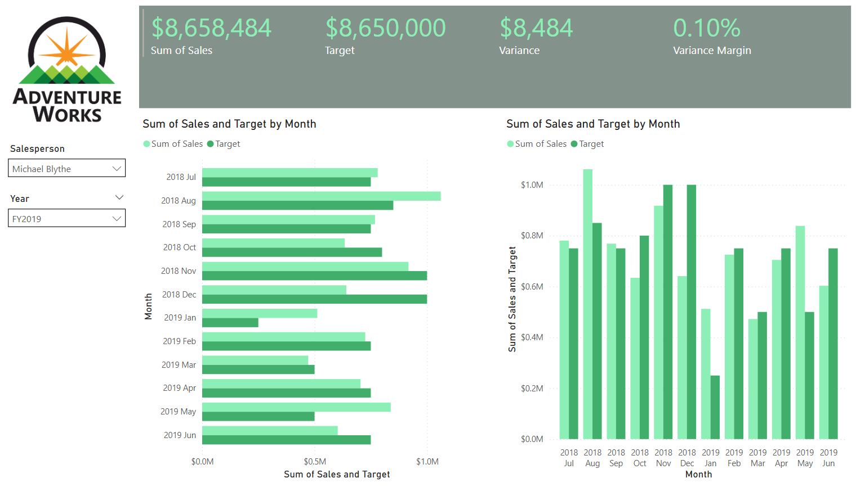  Syncing Sliders:  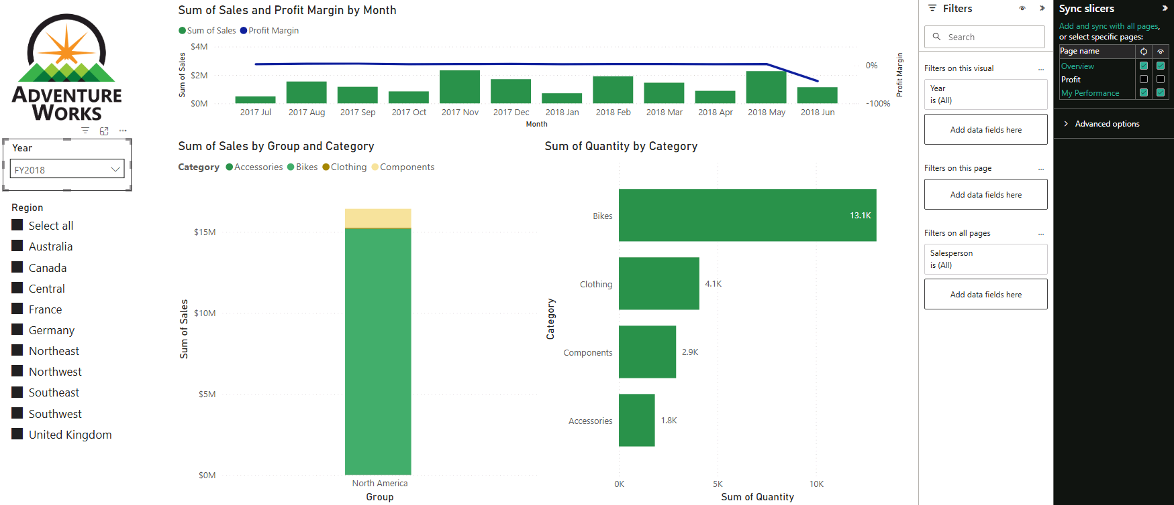  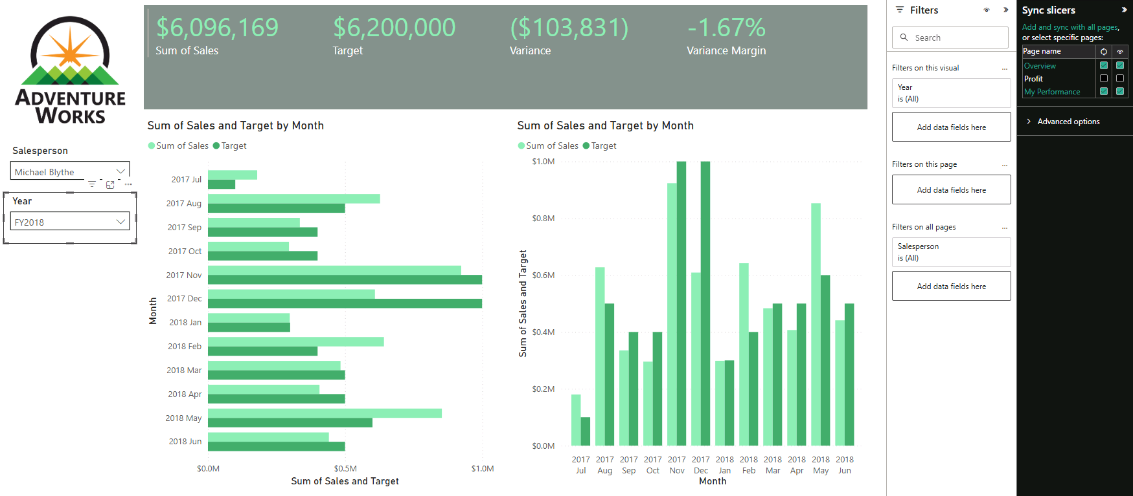

Course Notes

It is recommended to take notes from the course, use the space below to do so, or use the revision guide shared with the class:

Additional Information

We have included a range of additional links to further resources and information that you may find useful, these can be found within your revision guide.

END OF WORKBOOK

Please check through your work thoroughly before submitting and update the table of contents if required.

Please send your completed work booklet to your trainer.

